SUPERVISION
Canceled
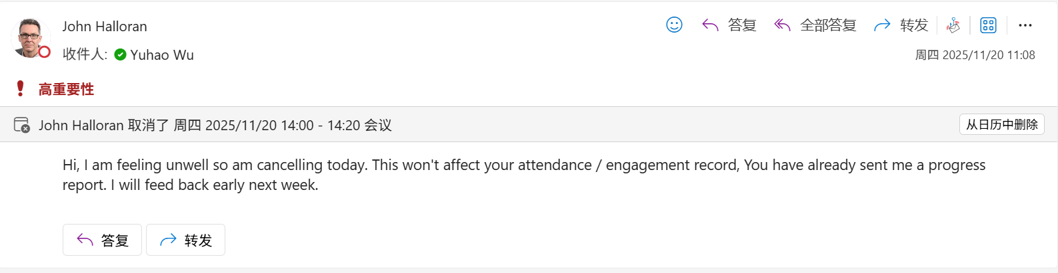

Email
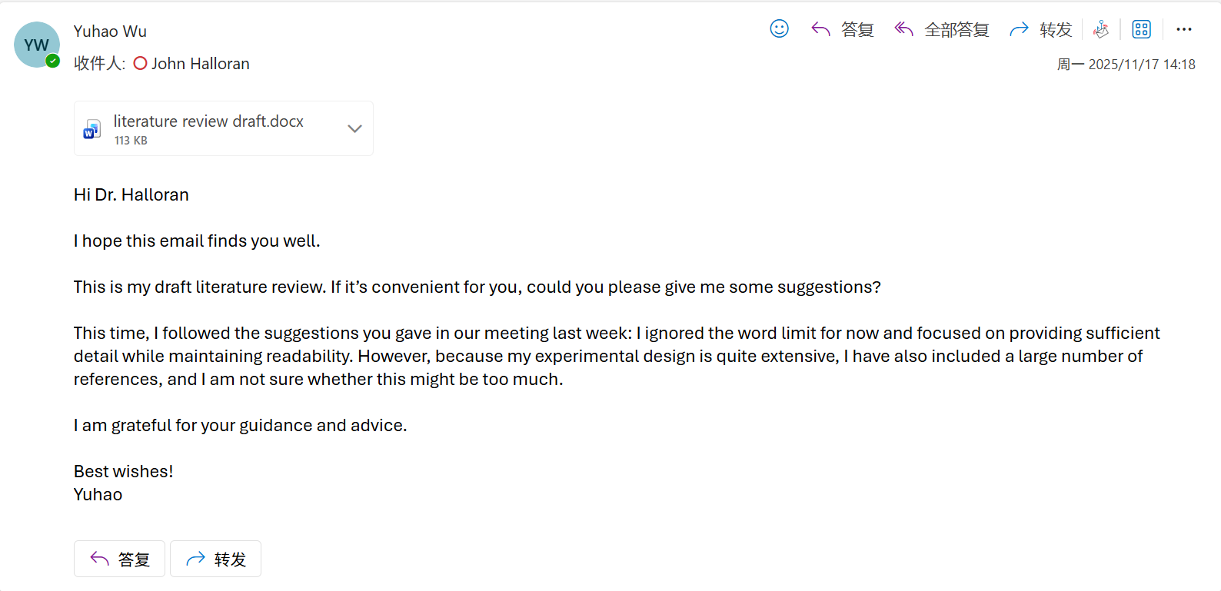
My supervisor did not reply because he was busy, so I plan to ask him in the next meeting.

Computing Project
WORK DONE
1. Complete the measurement of model size, inference latency, and energy consumption for all models.
2. Organise all the code from previous experiments and upload it to GitHub one by one.
3. Organise the project progress, especially the weekly progress reports, written explanations, email correspondence with my supervisor, meeting notes, etc.
4. I have designed a third new model, RCCMix.
5. Conduct an in-depth analysis of RCCMix and RCCMix lightweight.
6. Prepare the presentation and submit the slide deck on Aula.
7. Completed the statistical verification methods, model calibration, and error analysis experiments for the remaining models.

Issues and challenges
- How to make the GitHub structure and formatting clear and easy to understand for my supervisor.
2. Because there are many models, I can only select a few representative subsets for in-depth analysis.
3. Designing a new model is challenging because it requires considering the research question, dataset characteristics, the strengths and weaknesses of existing models, and the justification for the design choices.

Actions for next week
1. Complete the first draft of the dissertation.
2. If time allows, add more in-depth analysis and explanation of RCCMix.

